# Closed-loop experiments with CLoSES-SEM

## Up Front Summary

* Get code from:
  + **CLoSES-SEM**: Trial by Trial Neural Decoder Closed-loop system (to stimulate following decoded cognitive state)

(<https://github.com/Center-For-Neurotechnology/CLoSES-SEM.git>)

* Steps:
  1. Intracranial electrical brain signals from NSPs or acquisition boards are acquired,
  2. Bipolar or Referential montage,
  3. Band pass filtered,
  4. Features (power or coherence) continuously computed once a trial starts.
  5. After epochs specified in model (default 2s), features are averaged and used as input to decoder model.
  6. Decoder model runs and produces mean / boundaries estimates
  7. If state is above (below) thresholds, stimulation is triggered on the following trial (default).
* Key characteristics:
  + Features are computed per trial, averaged over time epochs, and a neural encoder/decoder model estimates a hidden state.
  + If decoded state is above (below) threshold, stimulation occurs on following trial.
* For safety, only N out of M trials can result on stimulation.
* It runs on a dedicated Simulink Real-Time computer with a GUI on another computer for configuration and real-time visualization.
* It runs in parallel to clinical and research systems.
* Replay of previously acquired datasets allows feature selection and model training.

# Hardware & Connections in the EMU

## Non-Stim day hardware & connections – with BlackRock NSP acquisition

* USB labeled CLoSES (connected to CLoSES computer in patient’s room).
* If tasks:
  + Presentation computer with task
  + Connect **image onset trigger** (CHANNEL 2 from Presentation Octopus) from presentation computer to NSP **AINP3** (corresponds to channel 131 on CLoSES GUI).
* Connect **channel 1** of octopus from CLoSES to **AINP2** (to have “Stimulation” on NSX file)
* Connect **channel 2-3** of octopus from CLoSES to **AINP5-6** (to have “Detections” events on NSX file)
* Connect **channel 5-8** of octopus from CLoSES to **AINP7-10** (to have “stim channel” on NSX file)
* All connections should be split to NSP2.

## Stim day hardware & connections– with BlackRock NSP acquisition

* All of Non-Stim hardware & connections (above)
* Connect an octopus cable to parallel port cable from CLoSES computer (labelled CLoSES).
  + Connect **channel 1** of octopus from the CLoSES to TRIGGER of Cerestim (this Triggers the Stimulation).
  + This BNC (Cerestim TRIGGER) should also be connected to NSP **AINP2**.
  + Connect the other channels to the other AINP inputs
* Stimulator (Cerestim)
  + Check connections (Headbox, power cord, and blue cables).
  + USB from Cerestim connected to Presentation computer (different for ECR!)
  + SYNC output connected to **AINP1**
  + CHECK that **TRIGGER** is connected to Octopus **channel 1 from CLoSES** and to **AINP2**
* Optional: Connect output from **Behavioral** GUI to NSP **AINP4** (corresponds to channel 132 on CLoSES GUI).

# Running CLoSES-SEM in the EMU

**Configuring CLoSES and GUI:**

* To Start CLoSES:
  + Connect USB key (black with label: CLoSES) to CLoSES target computer.
  + Turn on CLoSES target computer. (Black screen with “Simulink” on the bottom should appear on small monitor).
* On HOST computer (BlackRock Computer - #1):
  + Open MATLAB 2016b
  + Go to …\MATLAB\CLoSES\CLoSES-SEM (see below)
* In runClosedLoopStateEstimate.m edit participant name
* Run runClosedLoopStateEstimate.m
  + Alternatively:
* Add CLoSES-SEM to your path (right click on folder CLoSES-SEM and select Add to Path with SubFolders).
  + ClosedLoopWithNeuralModel should be on path. If it is not:
  + Type: GUINeuralDecoderClosedLoopConsole (‘PatientName’,**’MGxxx’**)
* RECOMMENDED change directory where data is saved: GUINeuralDecoderClosedLoopConsole('PatientName','test','dirResults','D:\DeciderData')

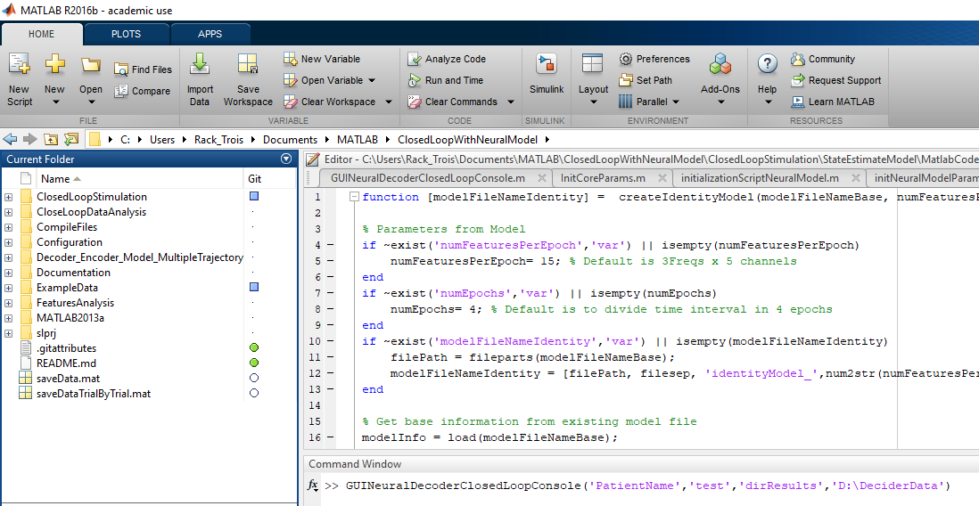

# Running CLoSES-SEM in Replay

CLoSES-RT can run on your Windows computer to replay data previously acquired.

**Running CLoSES-SEM:**

* + Open MATLAB 2016b
  + Go to …\MATLAB\CLoSES\CLoSES-SEM (see below)
* In runClosedLoopStateEstimate.m edit participant name
* Run runClosedLoopStateEstimate.m
  + Alternatively:
* Add CLoSES-SEM to your path (right click on folder CLoSES-SEM and select Add to Path with SubFolders).
  + ClosedLoopWithNeuralModel should be on path. If it is not:
  + Type: GUINeuralDecoderClosedLoopConsole (‘PatientName’,**’MGxxx’**)
* RECOMMENDED change directory where data is saved: GUINeuralDecoderClosedLoopConsole('PatientName','test','dirResults','D:\DeciderData')



# Operating the CLoSES-SEM GUI

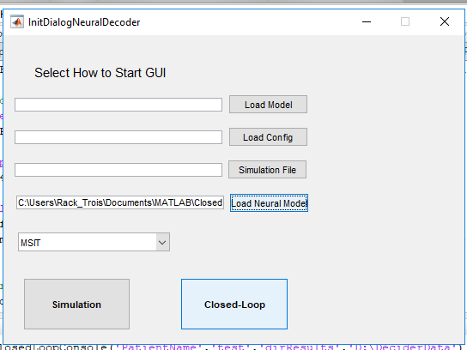

**On Initialization screen:**

* + Select ***EXPERIMENT TYPE*** on drop-down menu (e.g. MSIT)
  + Load Neural Model: select your model file from your directory (Usually on .\ExampleData)

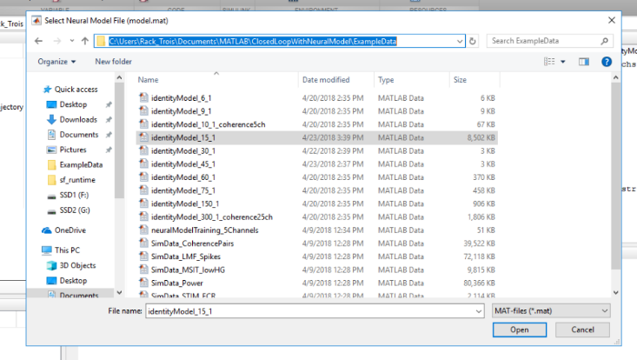

* + OPTIONAL:
  + If you want to load pre-determined channels or other parameters:
* Click on *Load Config* and look for configuration file (Default ones are on folder .\Configuration)
* *ConfigurationFile_MSIT_FixThreshold.m* for FIXED threshold
* Click on *Load Model* and look for MODEL file (*C:\Users\User\Documents\MATLAB* ClosedLoopWithNeuralModel*\ CompileFiles* *ClosedLoopStimXpcTarget_WithDecoderModel.dlm*)
* NOTE: If you are on directory C:\Users\User\Documents\MATLAB\ ClosedLoopWithNeuralModel no need to “load model”
* Click on *Closed-Loop* (to load main GUI)

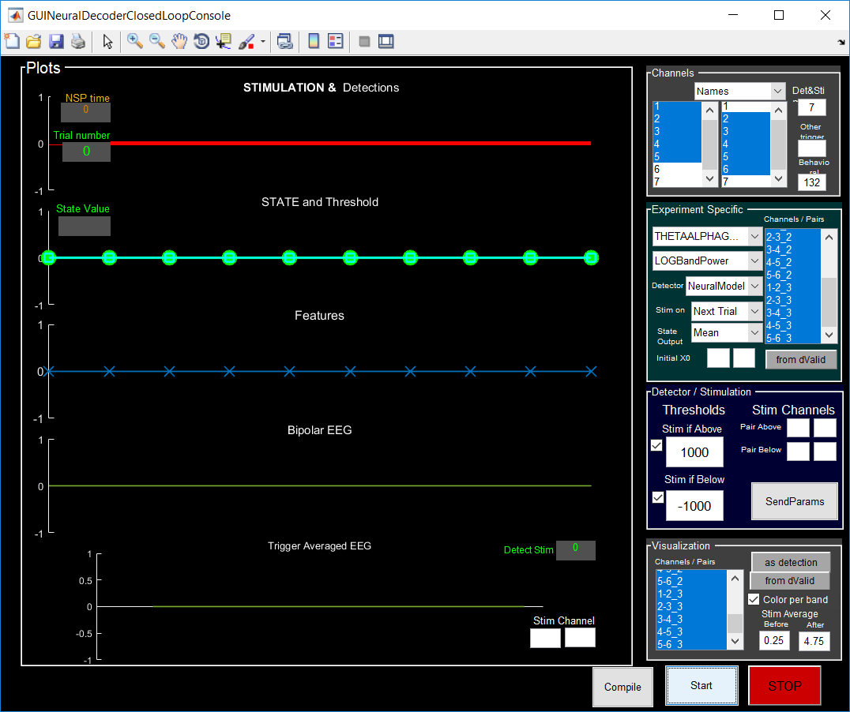**On CLoSES-SEM GUI**:

* + On Channels Panel: Select *contacts* (bipolar channels correspond to left-right pairs of contacts in order (e.g. 1-2; 2-3 etc.)
* *NOTE: NSP2 channels start at channel 201 (e.g. NSP channel 14 corresponds to channel 214 on CLoSES GUI)*

EXAMPLE:

* **BLOCK 1: Right selector: 232,233,234Left selector: 233,234,235**
  + **Right dACC- Channels RMF1-RMF2, channel numbers-: 232-233(NSP 2)**
  + **Right dACC- Channels RMF2-RMF3, channel numbers-: 233-234(NSP 2)**
  + **Right dACC- Channels RMF3-RMF4, channel numbers-: 234-235(NSP 2)**
* **BLOCK 2: Right selector: 27,28,29 Left selector: 28,29,30**
  + **Left dACC- Channels LMF1-LMF2, channel numbers-: 27-28 (NSP 1)**
  + **Left dACC- Channels LMF2-LMF3, channel numbers-: 28-29 (NSP 1)**
  + **Left dACC- Channels LMF3-LMF4, channel numbers-: 29-30 (NSP 1)**
* By Default, ALL features are selected as “Detection Channels/Pairs” to save all features (only those on dValid are processed by decoder model).
* OPTIONAL: Select as Visualization channels only those in dValid (only those used by model)
* Other Options should be double checked (see also figure below):

EXAMPLE: for MSIT with stimulation if Upper bound is larger than Threshold:

* Filter: THETAALPHAGAMMA
* Feature: LOGBandPower
* Detector: NeuralModel
* Stim on: Next Trial
* State Output: UpperBound
* Click on ***Compile***to Compile model (it will take 1-2min)
* Click on ***Start***to start Closed-Loop Stimulation System
* Click on ***Stop*** to stop and save file
  + - * + *There are 2 files: on for continuous data (EEG and stim) and one for trial by trial data (features, thresholds, state).*
        + Continuous Data File is called: DeciderData_EXPERIMENTTYPE_PATIENTNAME_DATE_TIME.mat

(e.g. DeciderData_MSIT_test_200301_0846.mat)

* + - * + Trial by Trial Data File is called: DeciderTrialByTrialData_EXPERIMENTTYPE_PATIENTNAME_DATE_TIME.mat (e.g. DeciderTrialByTrialData_MSIT_test_200301_0846.mat)

# When Running CLoSES-SEM GUI

* *Once started, you can change the threshold value and use SendParam to change the levels.* 
  + - * *Since MSIT only uses 1 threshold remove “ThBelow” by unchecking checkbox*
* Stop – Start after each block to get separate files.
  + - * REMEMBER: Only saves data to files when STOP is pressed.

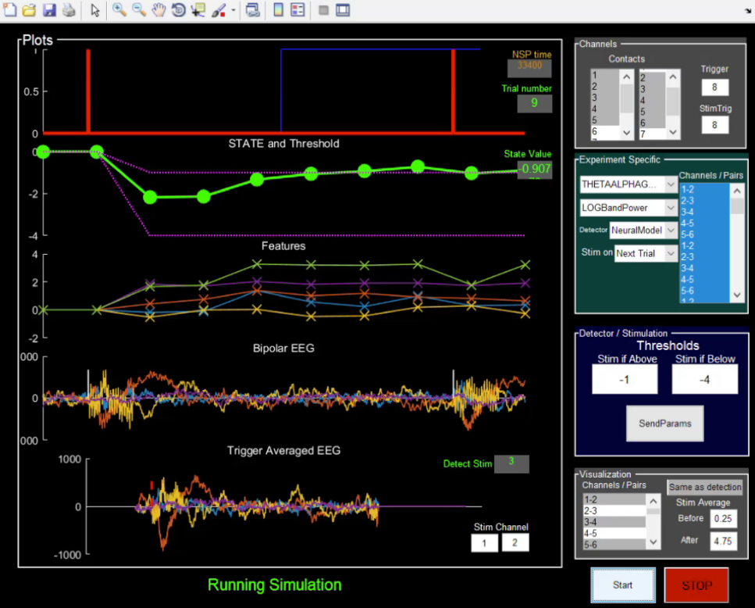

***NOTE: this GUI won’t do anything unless you have the task running, so start the task!***

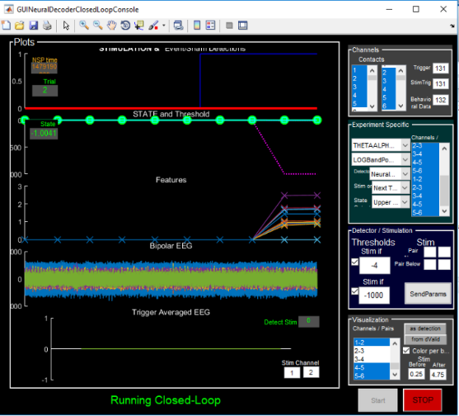

**Note when stim is happening, that it is occurring with trials and trial-based features.**

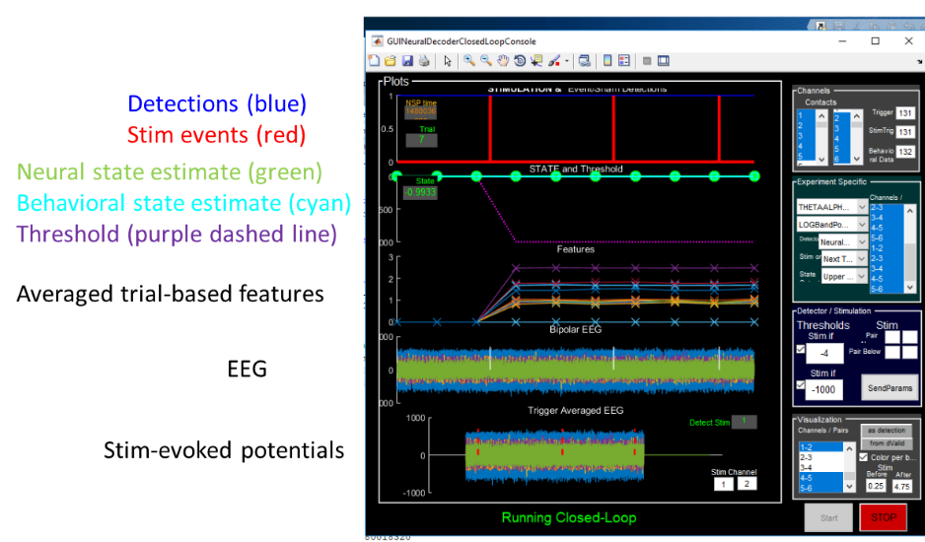

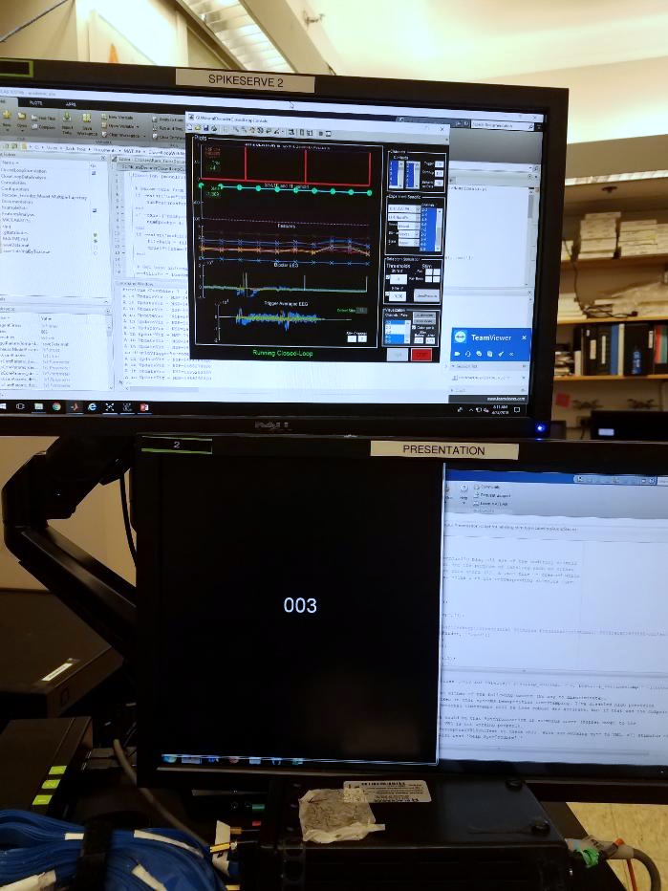

## Recover Data

* Data will be saved on Folder D:\DeciderData (or folder specified in ‘dirResults’,’DIRNAME’).
* Get the code from the components that generated the tasks and set up so that the code could be checked as to what it did per patient later
* Make sure to copy every file with today’s date on them (there will be 1 file per block)
  + Make sure to Stop/Start for each block

# Installing CLoSES-SEM

Get Git bash: <http://msysgit.github.io/>

Go to the Github TRANSFORM website: <https://github.com/Center-For-Neurotechnology/CLoSES-SEM.git>

Copy repository information to Clipboard<https://github.com/Center-For-Neurotechnology/CLoSES-SEM.git>

To get the code, go to the directory you want to install things, clone the project.

Step by step:

1. Open GitHub bash (<http://msysgit.github.io/> or terminal on Linux/MAC)
2. Go to the directory where CLoSES will be installed (**cd /D/MATLAB/CLoSES/CLoSES-SEM**).
3. Type: **git clone** <https://github.com/Center-For-Neurotechnology/CLoSES-SEM.git> **.**

(the last dot means here).

## Updating CLoSES-SEM code:

To update the code, open git bash, go to the directory you installed things and type: **git pull** (see example below).

The first time you will be asked to relate your copy to origin. Follow instructions on screen.

If you are updating on a computer for simulations, that’s it!

# Compiling model for the first time

If you are updating the RIG, it is a good idea to compile model before running GUI (see screenshot below).

1. In MATLAB type: initializationScriptNeuralModel('REAL-TIME','ExampleData/identityModel_15_1.mat')
2. Double-click on .\ClosedLoopStimulation\StateEstimateModel\ClosedLoopStimXpcTarget_WithDecoderModel.slx
3. Go to directory: **CompileFiles**
4. On model click the “Build model”
5. Get back to CLoSES-SEM root folder

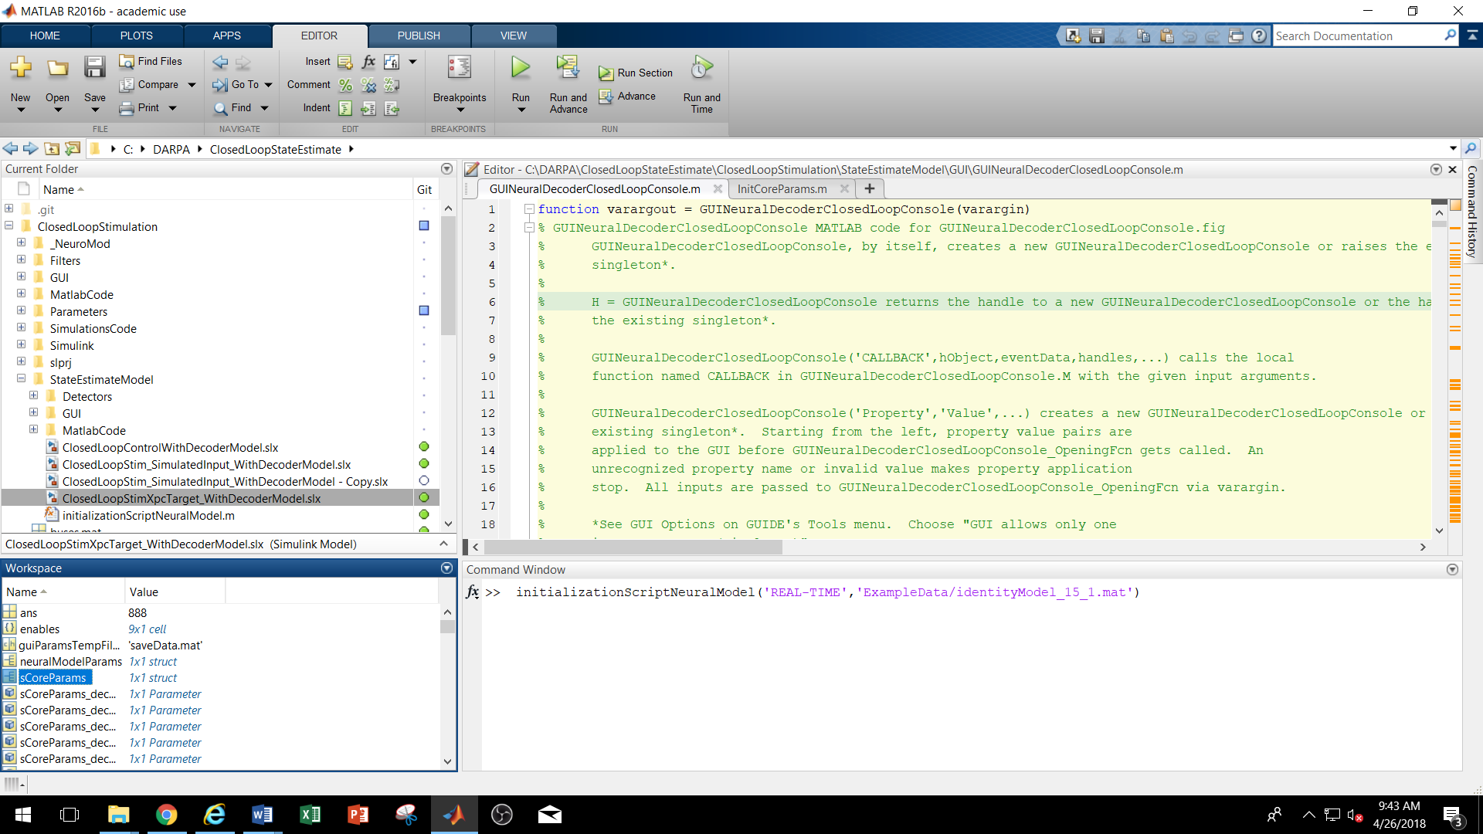

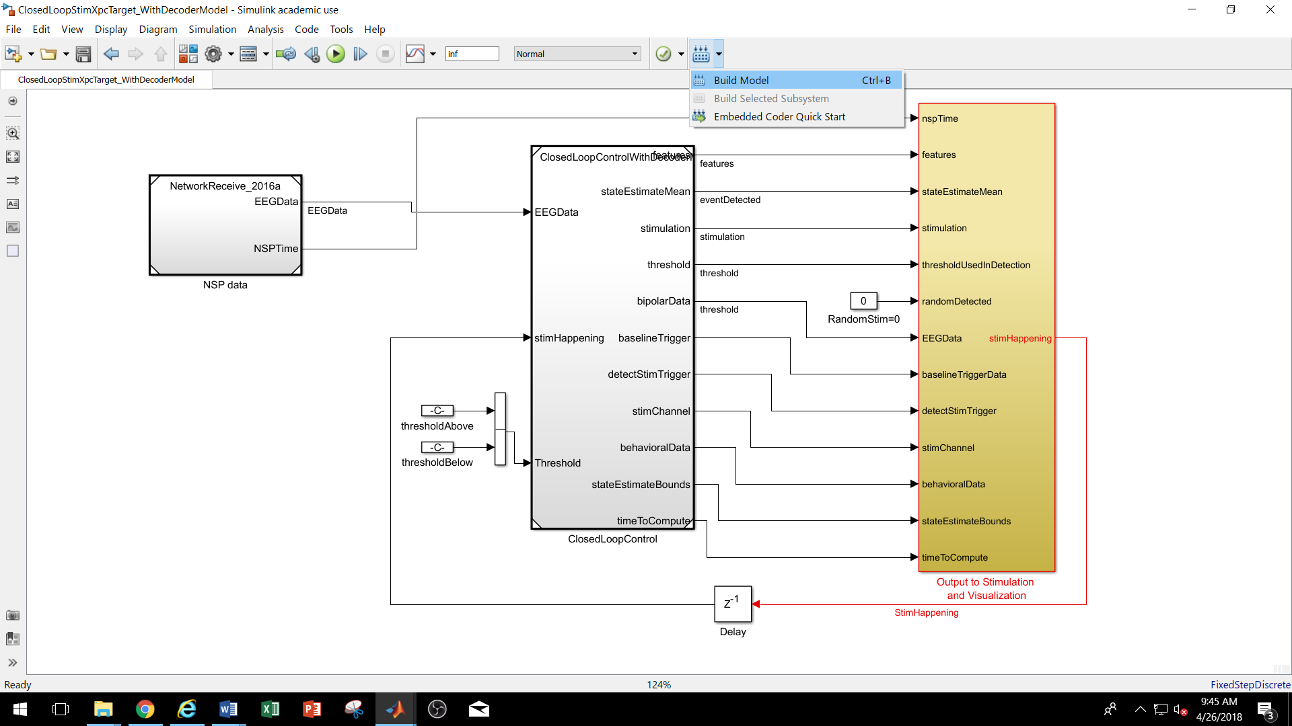

# Dependencies

MATLAB toolboxes:

* MATLAB
* Simulink
* Simulink Real-Time
* Signal Processing Toolbox
* Communications Toolbox
* DSP System Toolbox